Database Project – Group 3

**Student Id:** C03913555

**Student Names:** Utsav Bajracharya, Ranish Shrestha, Roshan Dhakal, Kusum Lamichhane, Bandana Pachabhaiya Magar

**Submitted date:** 05/11/2023

**Table of Contents**

**Part1 – Company Overview and Product** 1

Company Name 1

Company Overview/Description 1

Products 1

Product Attributes 1

**Part2 – Customer Sales Invoice** 2

**Part3 – Entity Relationship Diagrams** 3

ER diagram 3

**Product:** 4

**Company:** 4

**Part3 – Entity Relationship Diagrams** 7

ER diagram 7

**Product:** 7

**Company:** 7

# **Part1 – Company Overview and Product**

## Company Name

Oasis Hardware

## Company Overview/Description

Oasis Hardware company is specializing in the design, manufacturing, and distributing high-quality of different hardware products. It has consistently delivered different hardware solutions, exceptional services and gained customer satisfaction. Our mission is to become the oasis of reliable in hardware industry where people can find the perfect hardware solution that meet their needs, backed by strong support and services. Innovation is continuously run in Oasis Hardware Company where our research and development team constantly explore new technology, materials and design to create more reliable solutions. We value customer feedback and continuously refine our products and services.

## Products

Oasis Hardware company provides a wide range of goods and equipment for building, house renovation, maintenance, and repair. Our goal is to offer top-notch hardware solutions to a variety of sectors and uses. The products we have are known for their quality and reliability. Here are some of the products offered by our company:

**Safety Gears department** – In this department, we store safety gear and equipment to prioritize worker safety. We have everything you need, such as safety helmets, gloves, dust masks, knee pads, work boots, ear protection, eye protection.

**Electrical Supply department** – Electrical tools, Extension cords, Switches, Circuit breakers, Wiring, Electrical outlets, Electrical connectors

**Paint and painting supplies** – Paint color, Paint brushes, Rollers, Drop cloths, Painter tape and Paint trays

**Home appliances** – Flooring (Tiles, Laminate, Hardwood), locks, knobs, handles, shelving, and organizers for cabinets

## Product Attributes

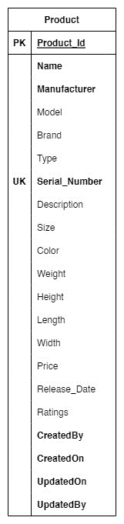

Figure 1 Product Attributes

## **Part2 – Customer Sales Invoice**

**Customer ID**: 0001 **Order ID**: 00001

**Customer Name**: ABCD Company **Order Date**: 05/11/2023

**Customer Address**: 333 N Rivermede Rd **Associate ID**: 501

Toronto, ON L4K 3N7 **Associate Name**: Bob Smith

|  |  |  |  |  |  |  |
| --- | --- | --- | --- | --- | --- | --- |
|  |  |  |  |  |  |  |
| **Product ID** | **Model** | **Brand** | **Description** | **Qty** | **Unit Price** | **Extended Price** |
| S011 | 62-12345 | Lawn-Boy | Helmets | 2 | 595.00 | 1190.00 |
| E668 | 59-98765 | Black & Decker | Switches | 1 | 1449.00 | 1449.00 |
| P763 | 36-59278 | Craftsman | Paint and brush | 2 | 625.00 | 1250.00 |
| H004 | 45-78233 | Craftsman | Locks | 1 | 150.00 | 150.00 |
|  |  |  |  |  |  |  |
|  |  |  |  |  |  |  |
|  |  |  |  |  | **Sub-total** | 4039.00 |
|  |  |  |  |  | **Tax** | 525.07 |
|  |  |  |  | **Invoice Total** | | 4,564.07 |

**Customer ID**: 0002 **Order ID**: 00002

**Customer Name**: XYZ Company **Order Date**: 07/11/2023

**Customer Address**: 1120 Newkirk Rd **Associate ID**: 502

Toronto, ON L4K 3N7 **Associate Name**: Robin

|  |  |  |  |  |  |  |
| --- | --- | --- | --- | --- | --- | --- |
|  |  |  |  |  |  |  |
| **Product ID** | **Model** | **Brand** | **Description** | **Qty** | **Unit Price** | **Extended Price** |
| S011 | 62-12345 | Lawn-Boy | Knee Pads | 10 | 200.00 | 2000.00 |
| E668 | 59-98765 | Black & Decker | Switches | 1 | 1449.00 | 1449.00 |
| E700 | 36-59278 | Craftsman | Electric Connectors | 2 | 625.00 | 1250.00 |
| H004 | 45-78233 | Craftsman | Locks | 1 | 150.00 | 150.00 |
|  |  |  |  |  |  |  |
|  |  |  |  |  |  |  |
|  |  |  |  |  | **Sub-total** | 4849.00 |
|  |  |  |  |  | **Tax** | 630.37 |
|  |  |  |  | **Invoice Total** | | 5,479.37 |

Product id:

**Safety Gears department** – S

**Electrical Supply department** – E

**Paint and painting supplies** – P

**Home appliances** –H

# **Part3 – Entity Relationship Diagrams**

## ER diagram

## **Product:**

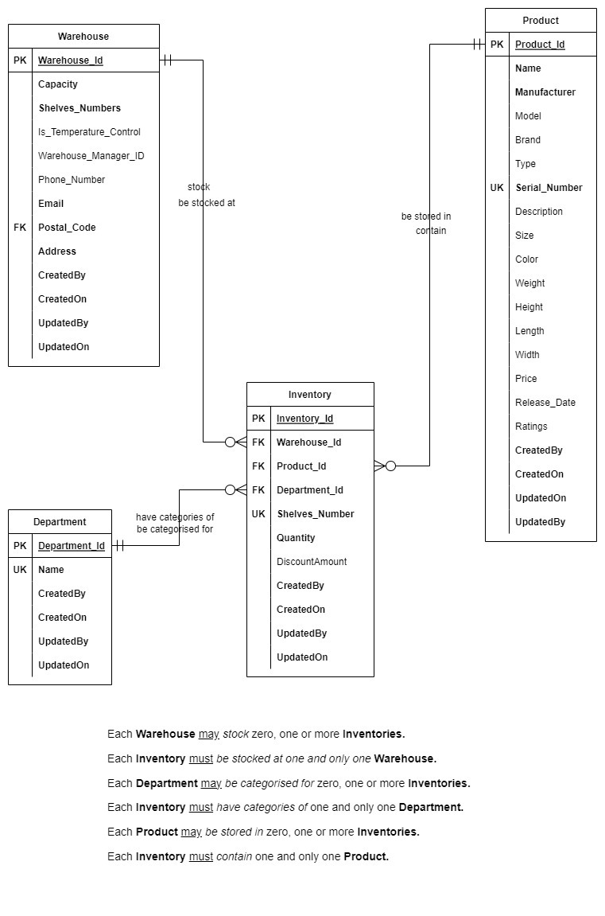

Figure 2 Product ER Diagram

### **Company:**

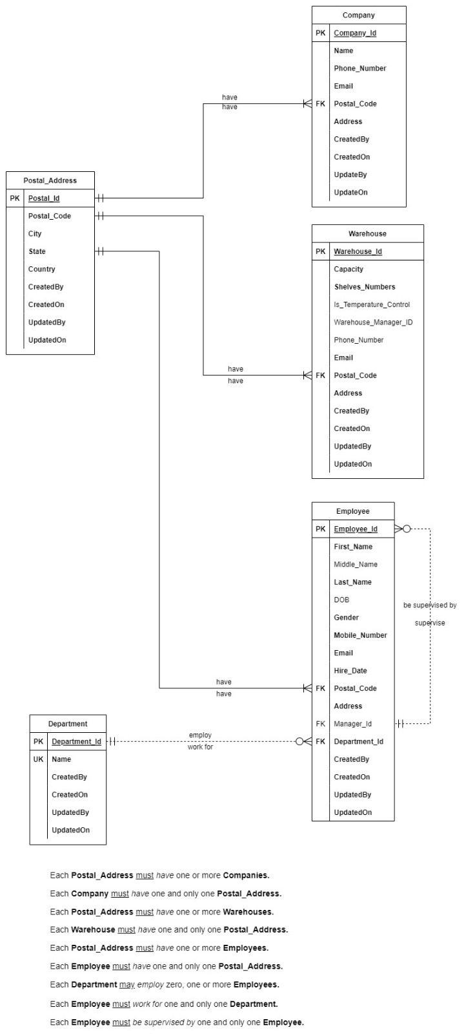

Figure 3 Company ER Diagram

**Customers:**

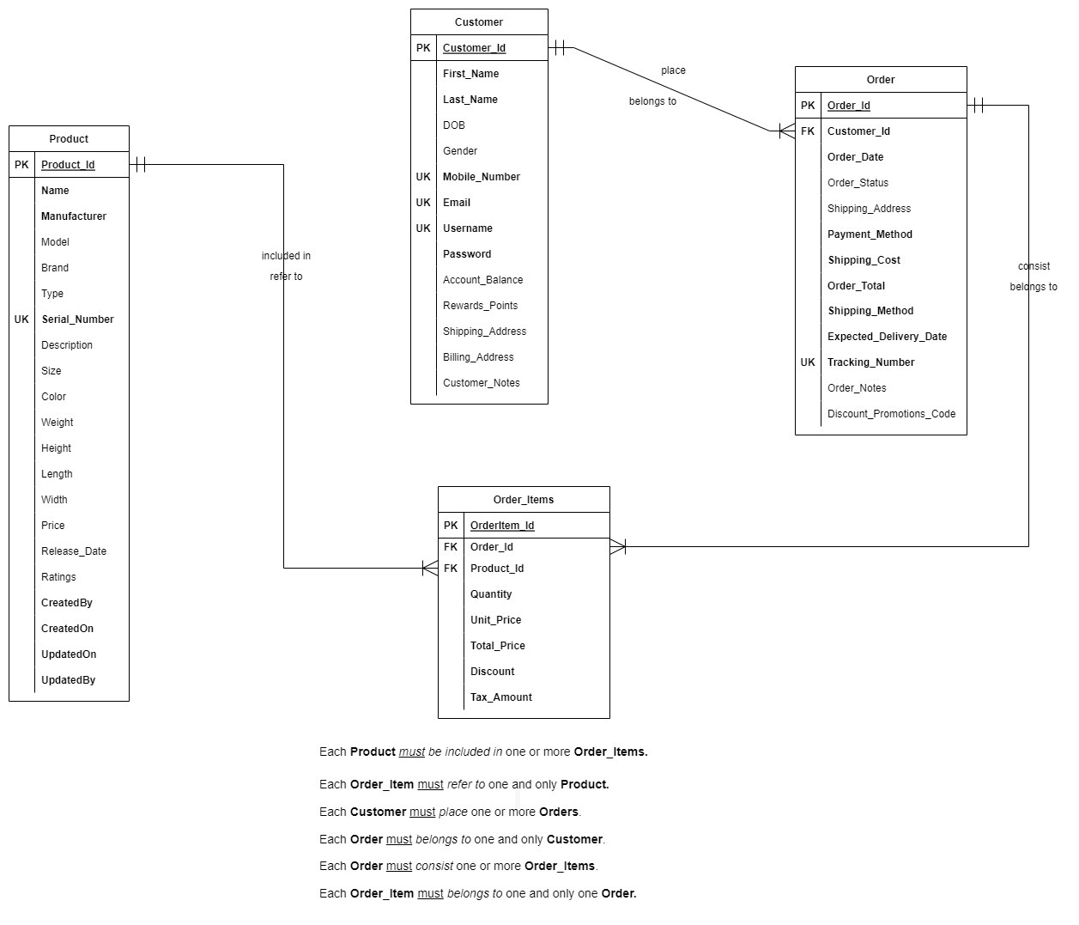

Figure 4 Customers ER Diagram

### Relational Schema

1. Product Table
   1. Relation Name: Product
2. Product_Id (Primary key, Integer)
3. Name (String)
4. Manufacturer (String)
5. Model (Integer)
6. Brand (String)
7. Type (String)
8. Serial_Number (Unique key, Integer)
9. Description (String)
10. Size (Integer)
11. Color (String)
12. Weight (Float)
13. Length (Float)
14. Width (Float)
15. Price (Float)
16. Release_Date (Integer)
17. Ratings (Float)
18. CreatedBy (String)
19. CreatedOn (Integer)
20. UpdatedOn (Integer)
21. UpdatedBy (String)
    1. Relation Name: Warehouse
       1. Warehouse_Id (Primary key, Integer)
       2. Capacity (Integer)
       3. Shelves_Numbers (Integer)
       4. Is_Temperatur_Control (Bollean)
       5. Warehouese_Manager_ID (Integer)
       6. Phone_Number (Integer)
       7. Email (Varchar)
       8. Postal_Code (Foreign key, Varchar)
       9. Address (Varchar)
       10. CreatedBy (String)
       11. CreatedOn (Integer)
       12. UpdatedBy (String)
       13. UpdatedOn (Integer)
    2. Relation Name: Inventory
       1. Inventory_Id (Primary key, Integer)
       2. Warehouse_Id (Foreign key, Integer)
       3. Product_Id (Foreign key, Integer)
       4. Department_Id (Foreign key, Integer)
       5. Shelves_Number (Unique key, Integer)
       6. Quality (Integer)
       7. DiscountAmount (Float)
       8. CreatedBy (String)
       9. CreatedOn (Integer)
       10. UpdatedBy (String)
       11. UpdatedOn (Integer)
    3. Relation Name: Department
       1. Department_Id (Primary key, Integer)
       2. Name (Unique key, String)
       3. CreatedBy (String)
       4. CreatedOn (Integer)
       5. UpdatedBy (String)
       6. UpdatedOn (Integer)
22. Company Table
    1. Relation Name: Company
       1. Company_Id
       2. Phone_Number
       3. Email
       4. Postal_Code
       5. Address
       6. CreatedBy (String)
       7. CreatedOn (Integer)
       8. UpdatedBy (String)
       9. UpdatedOn (Integer)
    2. Relation Name: Postal_Address
       1. Postal_Id (Primary key, Integer)
       2. Postal_Code (Varchar)
       3. City (String)
       4. State (String)
       5. Country (String)
       6. CreatedBy (String)
       7. CreatedOn (Integer)
       8. UpdatedBy (String)
       9. UpdatedOn (Integer)
    3. Relation Name: Warehouse
       1. Warehouse_Id (Primary key, Integer)
       2. Capacity (Integer)
       3. Shelves_Numbers (Integer)
       4. Is_Temperatur_Control (Bollean)
       5. Warehouese_Manager_ID (Integer)
       6. Phone_Number (Integer)
       7. Email (Varchar)
       8. Postal_Code (Foreign key, Varchar)
       9. Address (Varchar)
       10. CreatedBy (String)
       11. CreatedOn (Integer)
       12. UpdatedBy (String)
       13. UpdatedOn (Integer)
    4. Relation Name: Department
       1. Department_Id (Primary key, Integer)
       2. Name (Unique key, String)
       3. CreatedBy (String)
       4. CreatedOn (Integer)
       5. UpdatedBy (String)
       6. UpdatedOn (Integer)
    5. Relation Name: Employee
       1. Employee_Id (Primary key, Integer)
       2. First_Name (String)
       3. Middle_Name (String)
       4. Last_Name (String)
       5. DOB (Date)
       6. Gender (String)
       7. Mobile_Number (Integer)
       8. Email (Varchar)
       9. Hire_Date (Date)
       10. Postal_Code (Foreign key, Varchar)
       11. Address (Varchar)
       12. Manager_Id (Integer)
       13. Department_Id (Integer)
       14. CreatedBy (String)
       15. CreatedOn (Integer)
       16. UpdatedBy (String)
       17. UpdatedOn (Integer)
23. Customer Table

**Product** ()

**Company** ()

**Customer** ()

### Business Rules

Business rules for Oasis Hardware Company can help establish guidelines and standards for various aspects of your business operations. Here are some suggested business rules tailored for a hardware company like Oasis Hardware Company:

1. Quality Product
2. Customer Service
3. Inventory Management
4. Suppliers Relationship
5. Employee Training
6. Environment Responsibility
7. Data Security
8. Credit and Payment Policy
9. Marketing and Branding
10. Continues Innovations

Top of Form